Introduction: In this lab we will be determining the acceleration of gravity of a free falling object using a photogate and a picket fence. The goal of this experiment is to collect and compare the values of V0 and g We are supposed to drop the picket fence through photogate and record the values of m and b. We are supposed to obtain 3 graphs and do the calculations based on it. Lastly, we are supposed to generate 2 histograms for the values of g and V0.

**Good single run for the free fall experiment:**

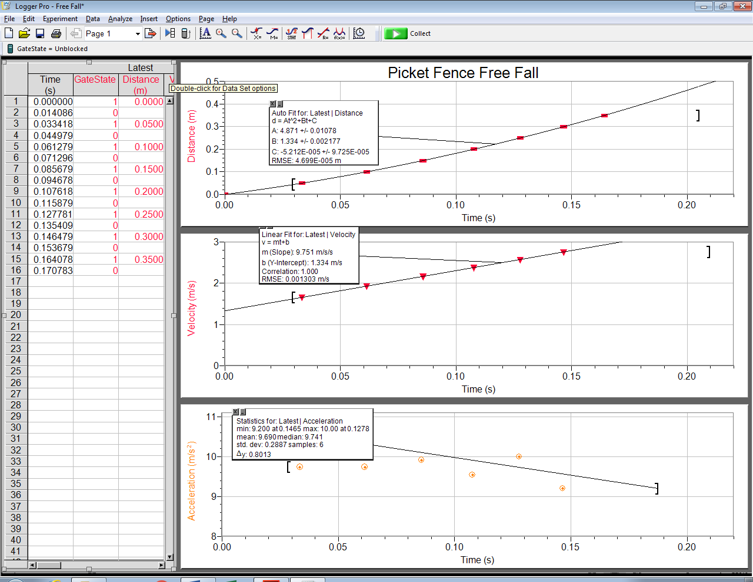

g= 9.743 m/s2, V0= 1.334 m/s

The acceleration values for the velocity and acceleration graph are close to each other (9.751 and 9.690). Out of two acceleration values the one that looks more accurate is the one obtained from the velocity graph because it is more linear.

**Histogram for g values:**

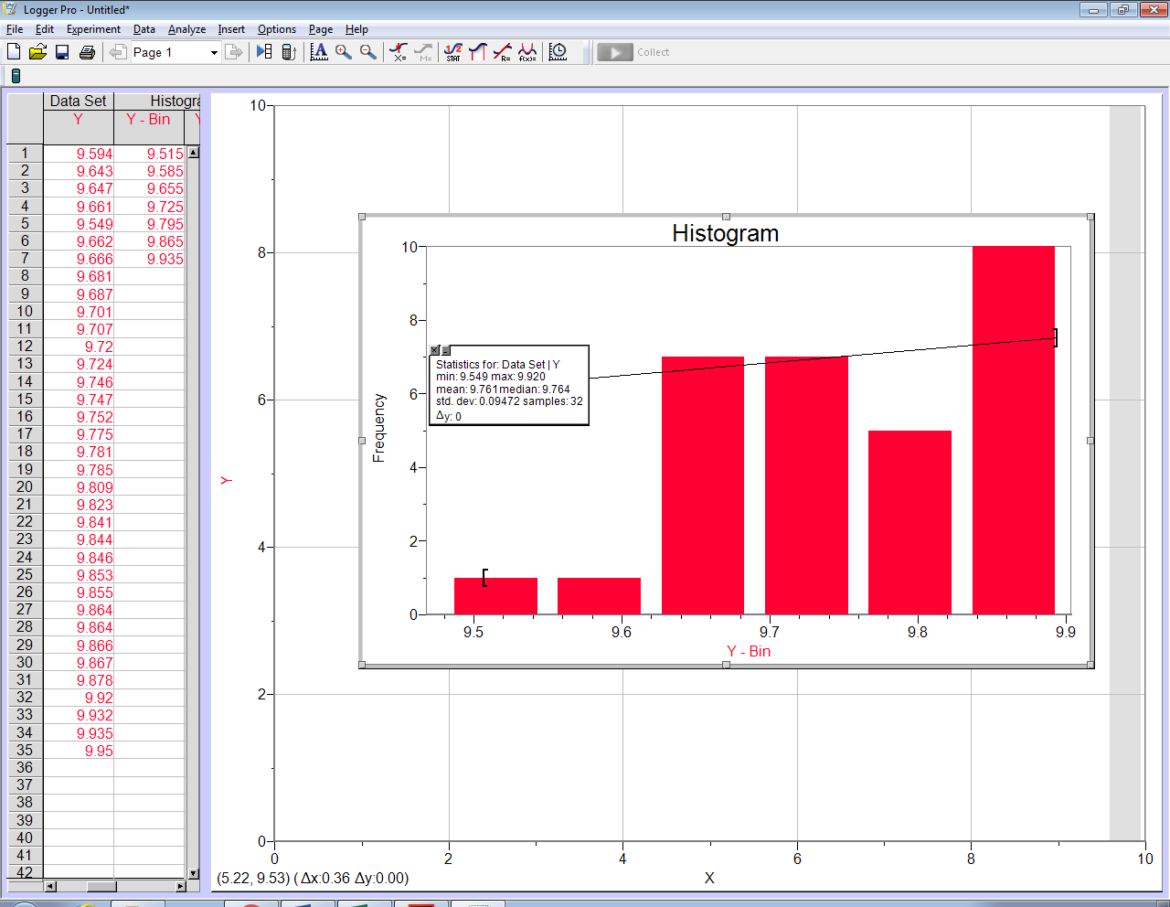

From the graph above the mean= 9.761, median= 9.764, and std dev= 0.09472.

The average value= 9.776429

**Histogram for V0 values:**

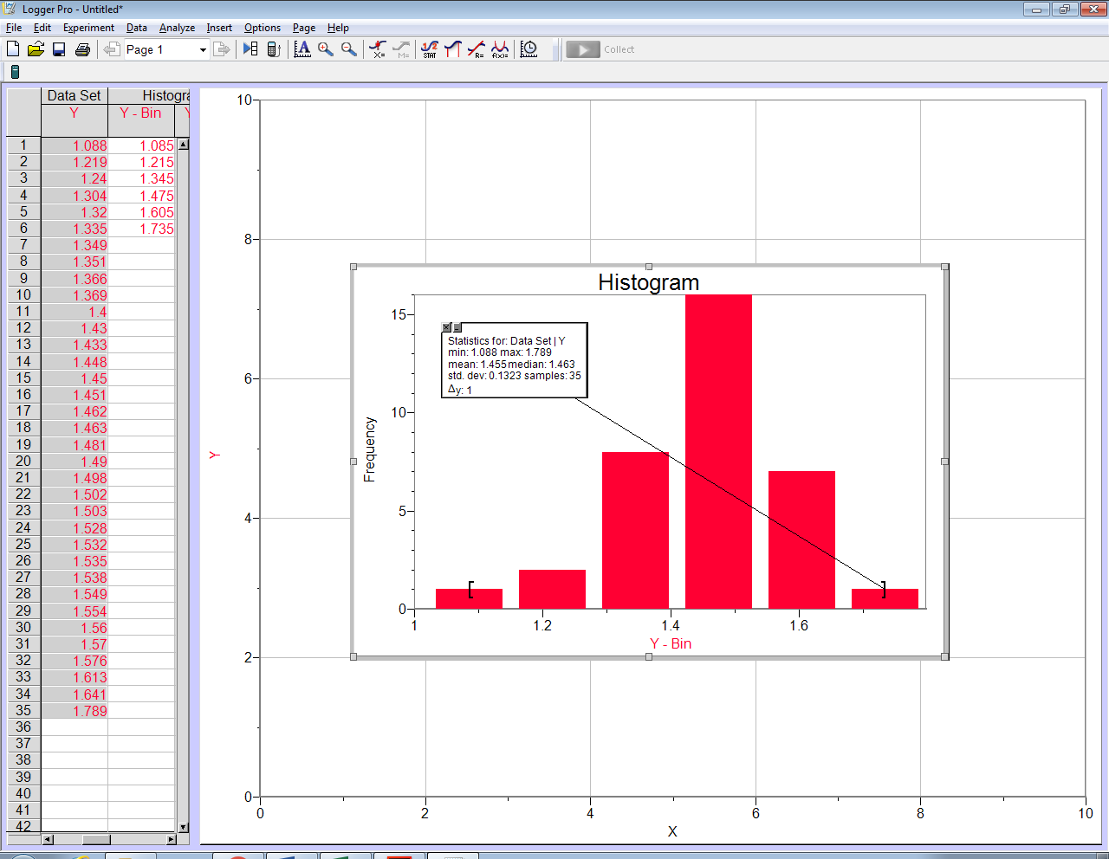

From the graph the mean= 1.455, median= 1.463, and std dev= 0.1323

The average value= 1.455343

9) The middle 2/3 values fall in the range of 9.681 to 9.853 approximately.

10) (9.95-9.594/2)= .178, this is the precision of the values being reported.

11) The uncertainty appears to be in the hundreds but it is only after the decimal, which represents less errors in precision.

Summary/Conclusion: In this lab we basically used a photogate and a picket fence to record the values of g and v0. And based on those values we created a histogram to better understand and represent those values. The values seemed to be accurate for the most part but there is a little bit of error (in hundreds), some possible source for errors can be the height from which the picket fence was dropped, velocity error and air resistance.

From this lab we can conclude that the acceleration due to gravity can be as close to 9.8m/s^2 but due to some errors the average turned out to be 9.707m/s^2. This was derived from the average of the recorded “g” or force of gravity. After 35 trials, we came to the above conclusion.